Merhaba Hocam..

Kullanıcı adı: 1

Şifre: 1

Dir.

Giriş Resmi:

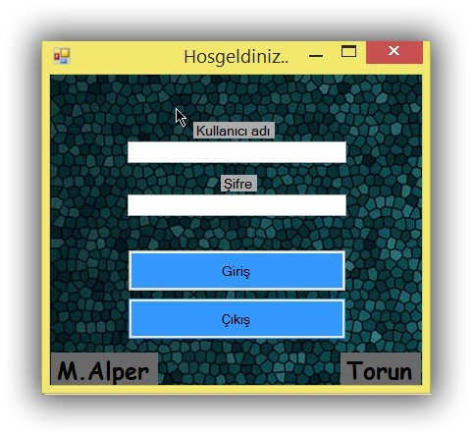

Şekil Main Menu

using System;

using System.Collections.Generic;

using System.ComponentModel;

using System.Data;

using System.Drawing;

using System.Linq;

using System.Text;

using System.Threading.Tasks;

using System.Windows.Forms;

using System.Data.OleDb;

namespace WindowsFormsApplication2

{

public partial class SifreliGiris : Form

{

public SifreliGiris()

{

InitializeComponent();

}

private void Form1_Load(object sender, EventArgs e)

{

}

private void button1_Click(object sender, EventArgs e)

{

OleDbConnection data = new OleDbConnection("Provider=Microsoft.ACE.OLEDB.12.0;Data Source=veritabani.accdb");

OleDbCommand komut = new OleDbCommand("Select * from veri", data);

data.Open();

OleDbDataReader read = komut.ExecuteReader();

while (read.Read())

{

if (textBox1.Text.ToString() == read["ıd"].ToString() && textBox2.Text.ToString() == read["sifre"].ToString())

{

form_Anasayfa anasayfa = new form_Anasayfa();

SifreliGiris.ActiveForm.Visible = false;

anasayfa.Show();

}

else

{

MessageBox.Show("Şifre yanlış");

}

}

data.Close();

}

private void textBox2_TextChanged(object sender, EventArgs e)

{

}

private void label2_Click(object sender, EventArgs e)

{

}

private void lbl_Hosgeldiniz_Click(object sender, EventArgs e)

{

}

}

}

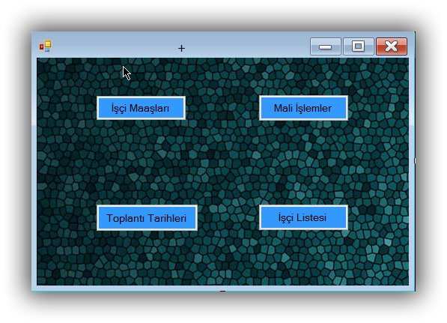

Şekil - User Operations

using System;

using System.Collections.Generic;

using System.ComponentModel;

using System.Data;

using System.Drawing;

using System.Linq;

using System.Text;

using System.Threading.Tasks;

using System.Windows.Forms;

namespace WindowsFormsApplication2

{

public partial class form_Anasayfa : Form

{

public form_Anasayfa()

{

InitializeComponent();

}

private void label1_Click(object sender, EventArgs e)

{

}

private void textBox1_TextChanged(object sender, EventArgs e)

{

}

private void button4_Click(object sender, EventArgs e)

{

İsci_Listesi isci = new İsci_Listesi();

isci.liste();

isci.Show();

}

private void form_Anasayfa_Load(object sender, EventArgs e)

{

}

private void button2_Click(object sender, EventArgs e)

{

Maliİslemler m = new Maliİslemler();

m.Show();

}

private void button3_Click(object sender, EventArgs e)

{

Toplanti_tarihleri toplanti = new Toplanti_tarihleri();

toplanti.Show();

}

private void btn_isci_maas_Click(object sender, EventArgs e)

{

isci_Maaslari isci_maasi = new isci_Maaslari();

isci_maasi.Show();

}

}

}

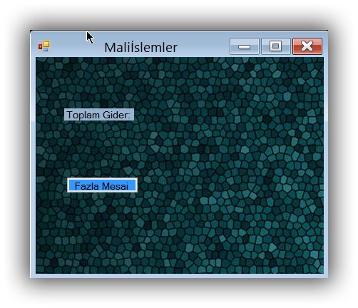

using System;

using System.Collections.Generic;

using System.ComponentModel;

using System.Data;

using System.Drawing;

using System.Linq;

using System.Text;

using System.Threading.Tasks;

using System.Windows.Forms;

using System.Data.OleDb;

namespace WindowsFormsApplication2

{

public partial class Maliİslemler : Form

{

OleDbConnection data = new OleDbConnection("Provider=Microsoft.ACE.OLEDB.12.0;Data Source=veritabani.accdb");

public Maliİslemler()

{

InitializeComponent();

}

private void button1_Click(object sender, EventArgs e)

{

FazlaMesai m = new FazlaMesai();

m.Show();

m.liste();

}

public int toplam_gider_hesapla() {

int toplam = 0;

OleDbCommand komut = new OleDbCommand("Select [Maas] from [isci liste]", data);

data.Open();

OleDbDataReader read = komut.ExecuteReader();

while (read.Read())

{

toplam += Convert.ToInt32(read["Maas"]) ;

}

data.Close();

return toplam;

}

private void Maliİslemler_Load(object sender, EventArgs e)

{

lbl_toplam_gider_goster.Text = Convert.ToString(toplam_gider_hesapla());

FazlaMesai f = new FazlaMesai();

f.liste();

}

}

}

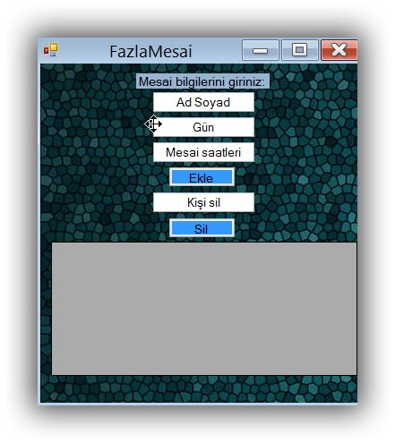

Şekil User Propery

using System;

using System.Collections.Generic;

using System.ComponentModel;

using System.Data;

using System.Drawing;

using System.Linq;

using System.Text;

using System.Threading.Tasks;

using System.Windows.Forms;

using System.Data.OleDb;

namespace WindowsFormsApplication2

{

public partial class FazlaMesai : Form

{

OleDbConnection baglanti = new OleDbConnection("Provider=Microsoft.ACE.OleDB.12.0; Data Source=veritabani.accdb");

OleDbDataAdapter veri_adapter;

OleDbCommand komut;

DataSet veri_set;

public FazlaMesai()

{

InitializeComponent();

}

void MesaiEkle()

{

try

{

komut = new OleDbCommand(@"INSERT INTO [Fazla Mesai]" +

"([Ad Soyad],[Gün],[Mesai Saati]) " +

"VALUES('" + textBox_Adsoyad.Text + "','" + textBox_gun.Text + "','" + textBox_mesai.Text + "')", baglanti);

baglanti.Open();

komut.ExecuteNonQuery();

MessageBox.Show("Ekleme Tamam!", "Ekle");

}

catch (Exception ev)

{

MessageBox.Show("" + ev.Message.ToString() + "", "Kayıt Hatası", MessageBoxButtons.OK, MessageBoxIcon.Warning);

}

baglanti.Close();

}

public void liste()

{

veri_adapter = new OleDbDataAdapter("Select [Ad Soyad],[Gün],[Mesai Saati]" +

"From [Fazla Mesai]", baglanti);

veri_set = new DataSet();

baglanti.Open();

veri_adapter.Fill(veri_set, "[Fazla Mesai]");

dataGridView1.DataSource = veri_set.Tables["[Fazla Mesai]"];

baglanti.Close();

}

void isci_sil()

{

komut = new OleDbCommand(@"delete from [Fazla Mesai] " +

"where [Ad Soyad]='" + textBox_Kisisil.Text + "'", baglanti);

baglanti.Open();

try

{

komut.ExecuteNonQuery();

MessageBox.Show("Silme işlemi Tamamlandı.");

}

catch (Exception ex)

{

MessageBox.Show("" + ex.Message.ToString() + "", "Silme Gerçekleşemedi!");

}

baglanti.Close();

}

private void FazlaMesai_Load(object sender, EventArgs e)

{

liste();

}

private void btn_ekle_Click(object sender, EventArgs e)

{

MesaiEkle();

liste();

}

private void btn_sil_Click(object sender, EventArgs e)

{

isci_sil();

liste();

}

private void lbl_bilgi(object sender, EventArgs e)

{

}

}

}

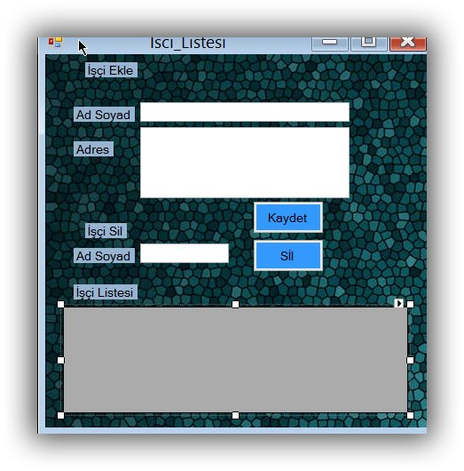

using System;

using System.Collections.Generic;

using System.ComponentModel;

using System.Data;

using System.Drawing;

using System.Linq;

using System.Text;

using System.Threading.Tasks;

using System.Windows.Forms;

using System.Data.OleDb;

namespace WindowsFormsApplication2

{

public partial class İsci_Listesi : Form

{

OleDbConnection baglanti = new OleDbConnection("Provider=Microsoft.ACE.OleDB.12.0; Data Source=veritabani.accdb");

OleDbDataAdapter veri_adapter;

OleDbCommand komut;

DataSet veri_set;

public İsci_Listesi()

{

InitializeComponent();

}

void isci_ekle() {

try

{

komut = new OleDbCommand(@"INSERT INTO [isci liste]" +

"([Ad Soyad],[Adres]) " +

"VALUES('" + textBox_Ad_Soyad.Text + "','" + textBox_Adres.Text + "')", baglanti);

baglanti.Open();

komut.ExecuteNonQuery();

MessageBox.Show("Ekleme Tamam!", "Ekle");

}

catch (Exception ev)

{

MessageBox.Show("" + ev.Message.ToString() + "", "Kayıt Hatası", MessageBoxButtons.OK, MessageBoxIcon.Warning);

}

baglanti.Close();

}

public void liste() {

veri_adapter = new OleDbDataAdapter("Select [Ad Soyad],[Adres]" +

"From [isci liste]", baglanti);

veri_set = new DataSet();

baglanti.Open();

veri_adapter.Fill(veri_set, "[isci liste]");

dataGridView1.DataSource = veri_set.Tables["[isci liste]"];

baglanti.Close();

}

void isci_sil() {

komut = new OleDbCommand(@"delete from [isci liste] "+

"where [Ad Soyad]='"+textBox_kisisil.Text+"'", baglanti);

baglanti.Open();

try

{

komut.ExecuteNonQuery();

MessageBox.Show("Silme işlemi Tamamlandı.");

}

catch (Exception ex)

{

MessageBox.Show("" + ex.Message.ToString() + "", "Silme Gerçekleşemedi!");

}

baglanti.Close();

}

private void İsci_Listesi_Load(object sender, EventArgs e)

{

liste();

}

private void btn_kaydet_Click(object sender, EventArgs e)

{

isci_ekle();

liste();

}

private void btn__sil_Click(object sender, EventArgs e)

{

isci_sil();

liste();

}

}

}

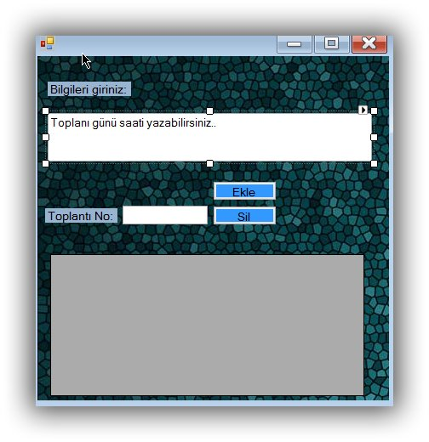

using System;

using System.Collections.Generic;

using System.ComponentModel;

using System.Data;

using System.Drawing;

using System.Linq;

using System.Text;

using System.Threading.Tasks;

using System.Windows.Forms;

using System.Data.OleDb;

namespace WindowsFormsApplication2

{

public partial class Toplanti_tarihleri : Form

{OleDbConnection baglanti = new OleDbConnection("Provider=Microsoft.ACE.OleDB.12.0; Data Source=veritabani.accdb");

OleDbDataAdapter veri_adapter;

OleDbCommand komut;

DataSet veri_set;

public Toplanti_tarihleri()

{

InitializeComponent();

}

void EklemeKomutu()

{

try

{

komut = new OleDbCommand(@"INSERT INTO [Toplantilar]" +

"([Toplanti]) " +

"VALUES('" + textBox_Toplanti + "')", baglanti);

baglanti.Open();

komut.ExecuteNonQuery();

MessageBox.Show("Ekleme Tamam!", "Ekle");

}

catch (Exception ev)

{

MessageBox.Show("" + ev.Message.ToString() + "", "Kayıt Hatası", MessageBoxButtons.OK, MessageBoxIcon.Warning);

}

baglanti.Close();

}

public void listele ()

{

veri_adapter = new OleDbDataAdapter("Select [Toplanti] "+

"From [Toplantilar]", baglanti);

veri_set = new DataSet();

baglanti.Open();

veri_adapter.Fill(veri_set, "[Toplantilar]");

dataGridView1.DataSource = veri_set.Tables["[Toplantilar]"];

baglanti.Close();

}

void Toplanti() {

komut = new OleDbCommand(@"delete from [Toplantilar] "+

"where [Toplanti]='" + textBox_Toplanti.Text + "'", baglanti);

baglanti.Open();

try

{

komut.ExecuteNonQuery();

MessageBox.Show("Silme işlemi Tamamlandı.");

}

catch (Exception ex)

{

MessageBox.Show("" + ex.Message.ToString() + "", "Silme Gerçekleşemedi!");

}

baglanti.Close();}

private void Toplantitarihleri_Load(object sender, EventArgs e)

{

listele();

}

private void Toplanti_tarihleri_Load(object sender, EventArgs e)

{

}

private void btn_sil_Click(object sender, EventArgs e)

{

}

private void textBox_Toplanti_TextChanged(object sender, EventArgs e)

{

}

private void btn_kaydet_Click(object sender, EventArgs e)

{

EklemeKomutu();

listele();

}

}

}